1. Open Selenium IDE and record a test that searches for a product on Flipkart, then generate and save the summary test report from the IDE after execution.
Ans=> open | https://www.flipkart.com/
click | <search-box-locator>
type | <search-box-locator> | laptop
click | <search-button-locator>
Test Suite: Flipkart Search Test
Test: Search for Product

Status: PASS
Steps Executed: 4
Failed Steps: 0
Result: Product search completed successfully

2. Manually capture a screenshot of a failed test step while automating a Zomato restaurant search scenario using Selenium IDE, and save the screenshot with a clear filename indicating the failed step.
Ans=> 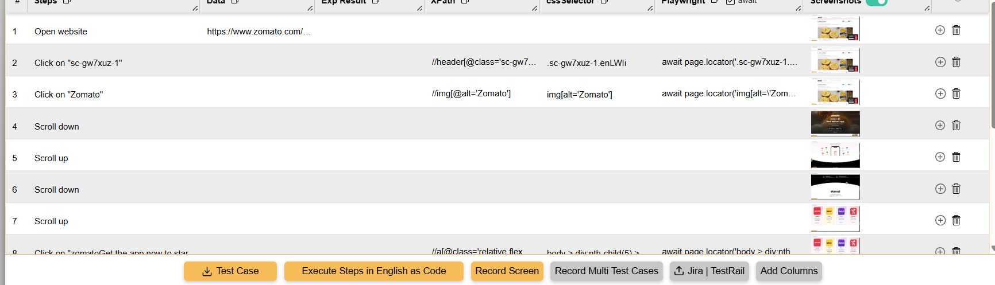

3. Use Selenium IDE's built-in command to automatically take a screenshot after adding an item to the cart in a Myntra shopping flow, then verify that the screenshot is saved in the correct location.
Ans=> 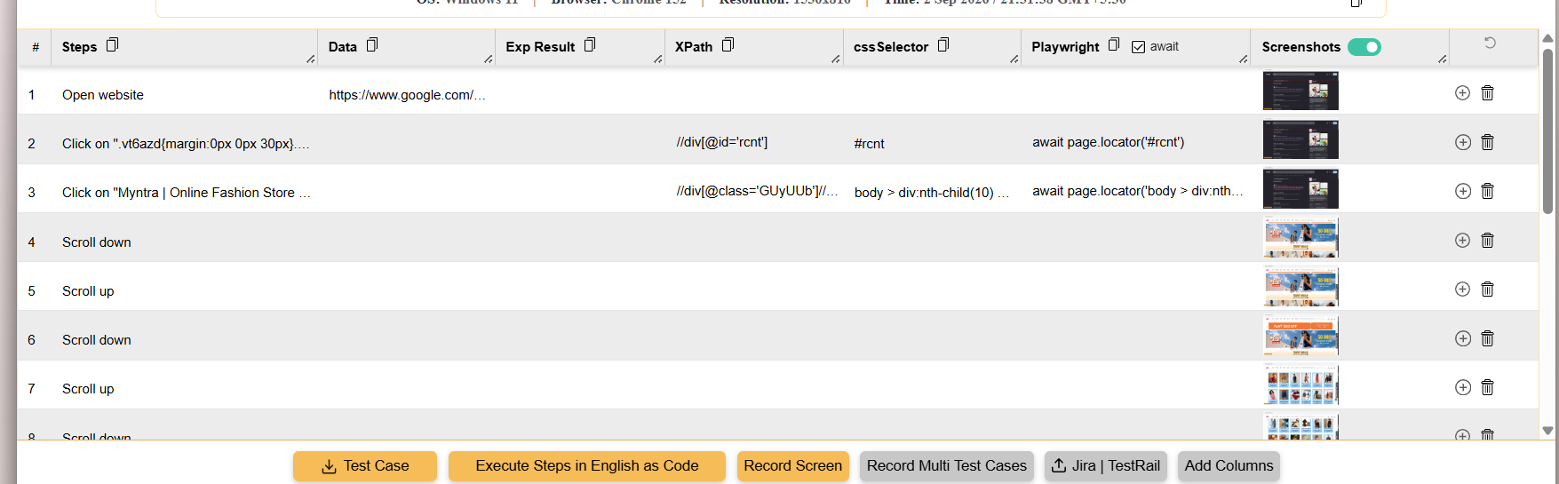

4. Given a test case that fails when searching for a movie on BookMyShow using Selenium IDE, use the IDE's debugging tools to identify the step causing the failure and write a short explanation of how you fixed it.<br><br><em><strong>Hint:</strong> Use breakpoints or step-by-step execution to isolate the problem.</em>
Ans=> 